UMBANE (UMB) Attested Carbon and Energy Token Summary
by David Robert Lewis
[This is a draft document]

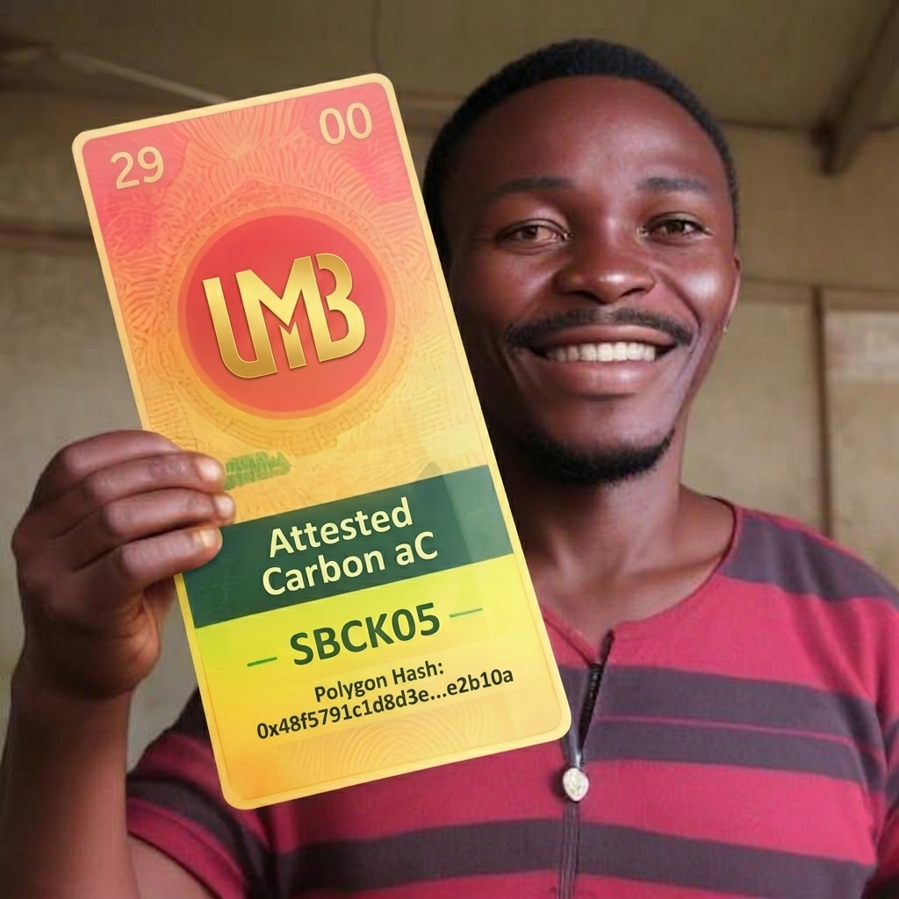

The process begins with the Generation phase, where solar panels generate electricity. An IoT device, verified by a Chainlink Oracle, measures this milliJoule (mJ) output and transmits the data to a blockchain smart contract.
In the Verification & Tokenization phase, the smart contract receives the energy data and creates a digital certificate that includes the Attested Carbon (aC) value. It then mints the UMB Governance Token, which acts as a standardized EC20 digital asset by wrapping both the raw energy data (mJ) and the certified carbon value (aC) in full compliance with D-REC standards.
This leads to the User Actions & Outcomes phase, where users can hold UMB to represent their verified renewable energy and participate in various pathways:
- Voluntary Markets: They can pledge UMB to receive a Pledged Carbon Certificate (cARB), which is retired for official sustainability claims.
- Liquidity & Trade: Users can trade UMB on open markets or within the community.
- Exchange for Credits: For automatic pathways, a carbon desk can instantly buy the UMB, facilitating an efficient trade for standard carbon credits.
- Governance token: Holders of UMB may participate in governance of the project DAO via the Sig-Council. (We have yet to configure the exact voting procedure and weighting)
- Fungability: Holders may trade UMB for stablecoin or other tokens, provide liquidity pools, staking and DeFi via any number of token methodologies.
- NFT token can be minted as recognition of a successful carbon retirement.

Image: This visual breakdown captures the entire technical process of the Umbane ecosystem on the Polygon network.

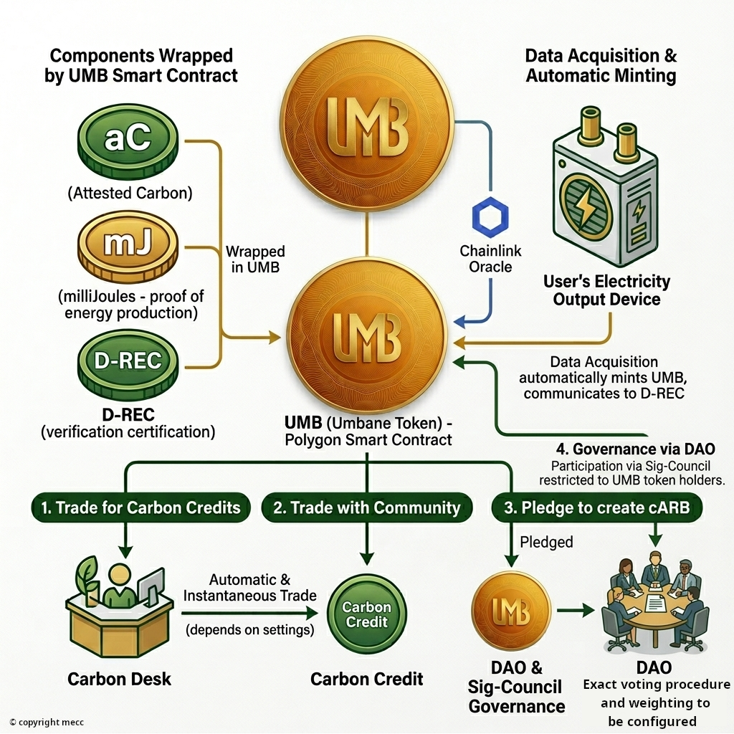

Document Prepared For: Umbane Stakeholders
Date: March 20, 2026
Version: 1.0
Authors: Umbane Research Team
Contact: 082 4251454
Email: ubuntupunk@gmail.com

